Kickstarter highlights

# What do we learn?

## People Loves Entertainment

Top 3 most successful category are **theater, music, and video**.  
 Most successful are defined as having bigger “successful” project compared to other projects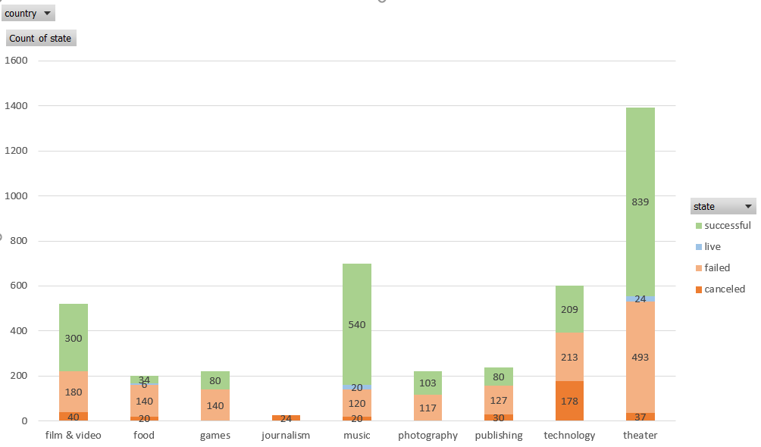

Figure 1: Theater, music, and video are the most successful categories

## However, Nothing Is Created Equal

In theatre, the “plays” sub-category has significantly more interest compared to “musical” and “spaces”. In music category, rock and indie rock has better success rate. Jazz, faith, and world music are the least successful.  
This hammers the idea that you have to pay attention to the sub-category before launching your project.

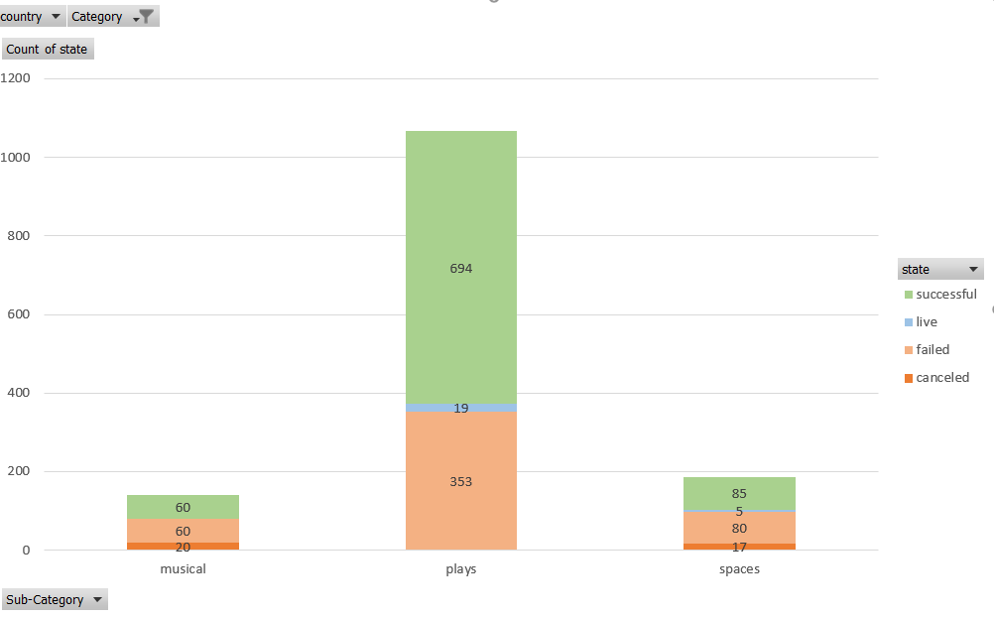

Figure 2: In Theater, plays significantly has more successful projects

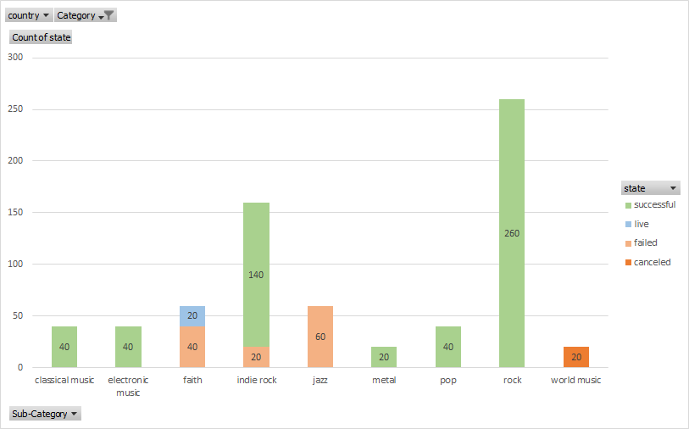

Figure 3: Rock and indie rock are more successful. World music, jazz, and faith are the least successful.

## Most Successful Projects Are in USA

Majority of the project is in USA. This might reflect Kickstarter’s user base.  
This could means that if you want to be successful, you might need to market heavily toward USA.

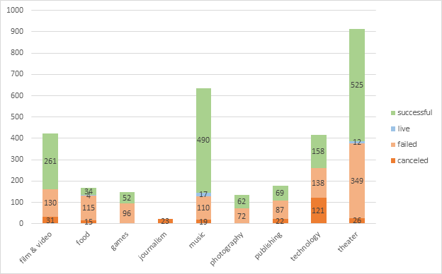

Figure 4: Nearly all of projects are started in USA

* Most “competitive: (highest number of project, lowest success rate)
* Is this trend the same year over year?

## Most & Least Successful Launch Month

Projects launched in May has the most successful launch compared to other months of the year. December has the worst success rate in all other months.

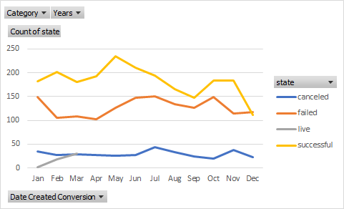

# Limitations of dataset

First, take a look at a live kickstarter such as [this](https://www.kickstarter.com/projects/euthia/euthia-torment-of-resurrection?ref=section-homepage-view-more-recommendations-p1)

There are important metrics that are left out on this excel sheet

* **Number of Comments:** show how much people are excited about this project. Kickstarter are driven by hype, and comments show this hype.
* **Number of Updates:** show how dedicated the developer is. If you research about kickstarter projects on reddit, most users are anxious when there are lack of updates.
* **Stretch Goals:** When the level of funding reaches certain level, more items are added to the project. Coming from personal experience, stretch goals really drive the hype, and should not be left out.
* **Number of Tiers, and price:** People who pay higher tier will be able to get exclusive access to whatever the creator decides. Considering that some higher tier are 7 times more expensive than normal tier (or more), this metric is important to consider.

# Possible tables or graphs that can be created?

The questions yet to be answered with current datasets are:

* What is the goal I have to set, if my project is about games, film, or music?

On average, those who are successful has significantly higher goal. This could mean that people are more interested in backing truly big project… but not always! Such as in journalism and food.

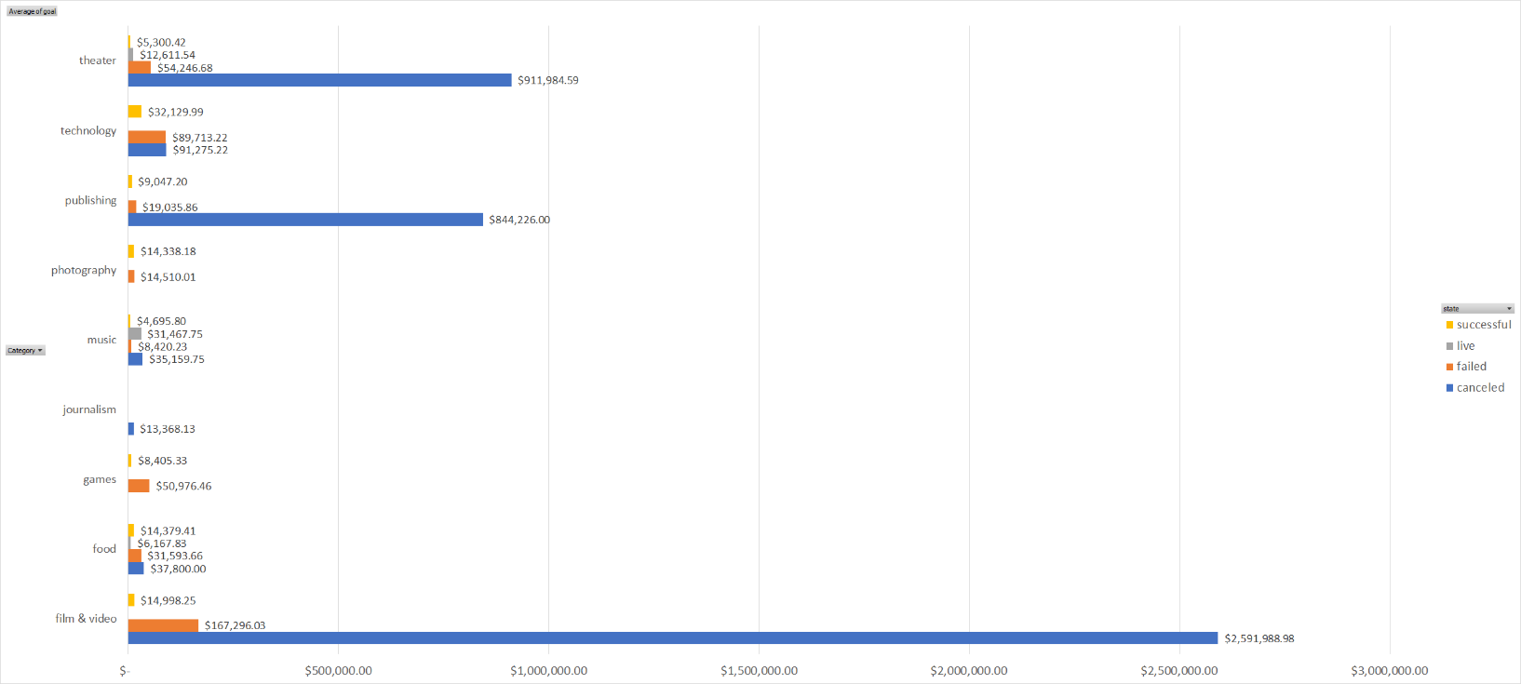

* How long my project should be?

It depends on the category, but somewhere around 30-33 days tend to be successful. Those in 35 or above tend to be less successful

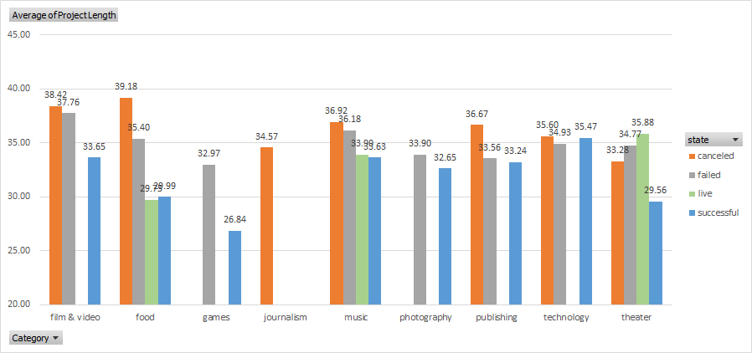

* Does being spotlighted help to make my project successful?

If you are not featured, you won’t be successful.

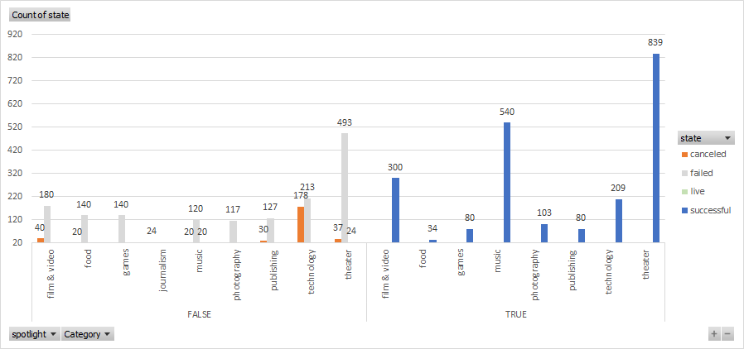

Bonus 2:

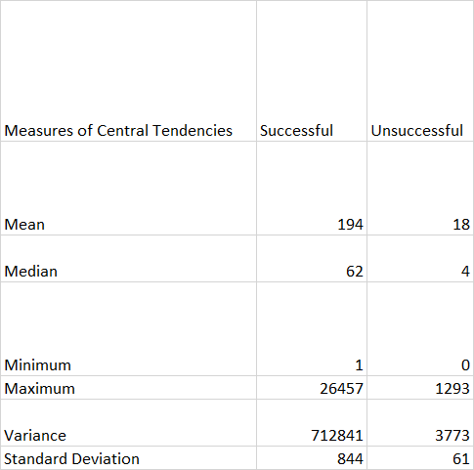

The median is more useful than mean because the standard deviation in both cases are very high (bigger than the mean itself). This likely means the result are skewed to some direction, and not a normal distribution.

The variability of number of backers with successful campaigns are higher on successful campaigns. Taking into accounts of previous charts, this make sense because different categories can succeed with much fewer number of backers than other categories (film & video compared to journalism for example).